Melissa Lawrence, CSD 340, Assignment 3.2, 06/08/2024

GitHub: <https://github.com/melkatlaw/csd-340.git>

GitHub Deployment: [Melissa Lawrence's CSD 340 Landing Page (melkatlaw.github.io)](https://melkatlaw.github.io/csd-340/)

HTML Check:

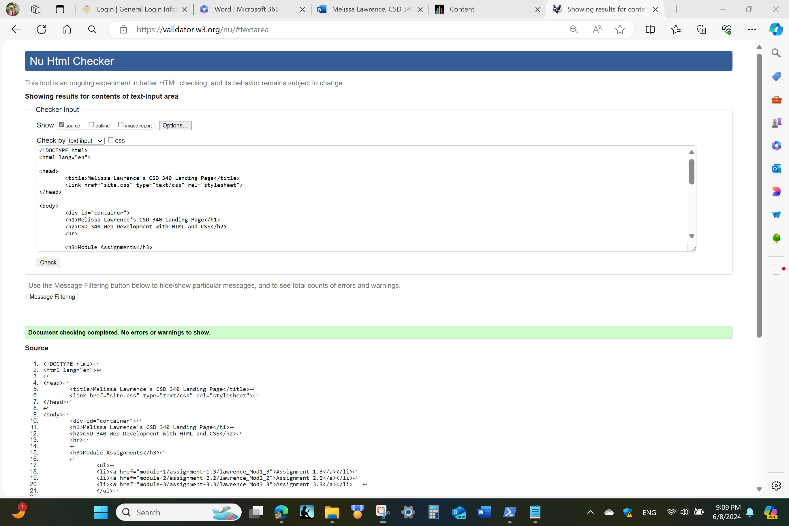

CSS Check:

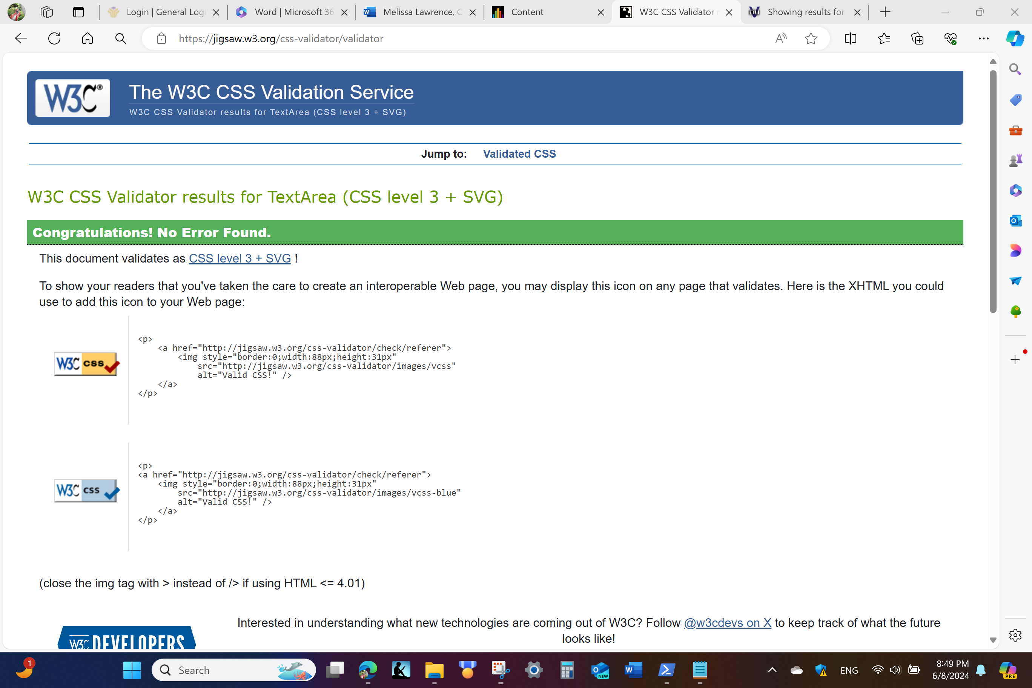

Landing Page:

